Anna Calderon

Harvard Forest

gDistance Notes

27 June 2016

Raster Layers

What is raster data? In its simplest form, a raster consists of a matrix of cells (or pixels) organized into rows and columns (or a grid), as shown in the graphic below, where each cell contains a value representing information, such as temperature.  Rasters are digital aerial photographs, imagery from

­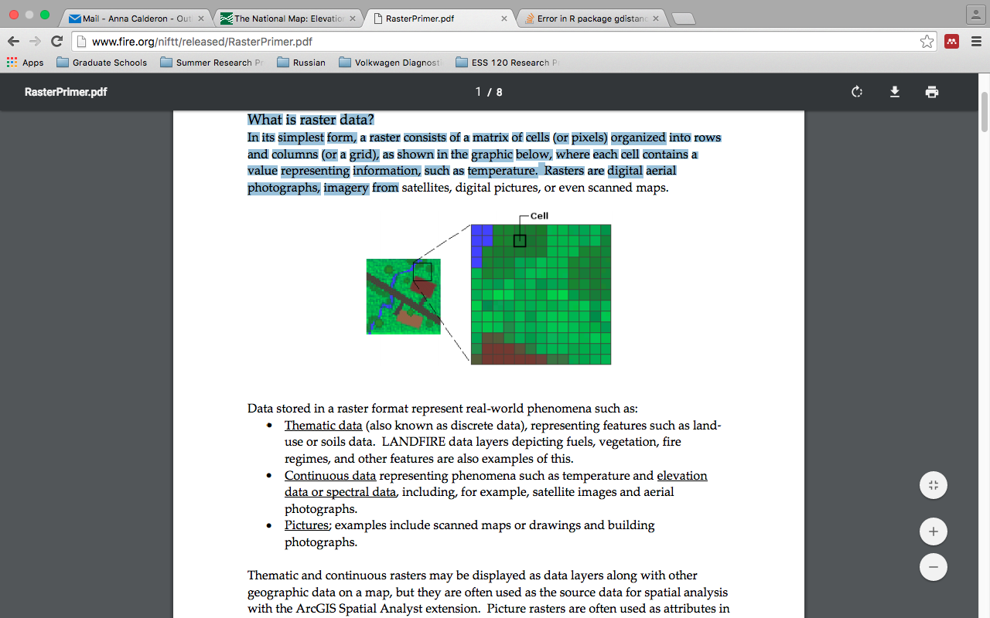

Create a Transition object from a RasterLayer or RasterBrick object. Transition values are calculated with a user-defined function from the grid values.